

oneM2M
Technical Report
Document Number | oneM2M-TR-0044-V-0.2.0
Document Name: | Heterogeneous identification service
Date: | 2018-03-13
Abstract: | This technical report investigates the various IoT ID standards and application requirements, discussion on how to be compatible with the IoT ID standards, and providing the heterogeneous identification service.
Template Version:23 February 2015 (Dot not modify)

This Specification is provided for future development work within oneM2M only. The Partners accept no liability for any use of this Specification.
The present document has not been subject to any approval process by the oneM2M Partners Type 1. Published oneM2M specifications and reports for implementation should be obtained via the oneM2M Partners' Publications Offices.

About oneM2M
The purpose and goal of oneM2M is to develop technical specifications which address the need for a common M2M Service Layer that can be readily embedded within various hardware and software, and relied upon to connect the myriad of devices in the field with M2M application servers worldwide.
More information about oneM2M may be found at: http//www.oneM2M.org
Copyright Notification
© 2016, oneM2M Partners Type 1 (ARIB, ATIS, CCSA, ETSI, TIA, TSDSI, TTA, TTC).
All rights reserved.
The copyright and the foregoing restriction extend to reproduction in all media.

Notice of Disclaimer & Limitation of Liability
The information provided in this document is directed solely to professionals who have the appropriate degree of experience to understand and interpret its contents in accordance with generally accepted engineering or other professional standards and applicable regulations. No recommendation as to products or vendors is made or should be implied.
NO REPRESENTATION OR WARRANTY IS MADE THAT THE INFORMATION IS TECHNICALLY ACCURATE OR SUFFICIENT OR CONFORMS TO ANY STATUTE, GOVERNMENTAL RULE OR REGULATION, AND FURTHER, NO REPRESENTATION OR WARRANTY IS MADE OF MERCHANTABILITY OR FITNESS FOR ANY PARTICULAR PURPOSE OR AGAINST INFRINGEMENT OF INTELLECTUAL PROPERTY RIGHTS. NO oneM2M PARTNER TYPE 1 SHALL BE LIABLE, BEYOND THE AMOUNT OF ANY SUM RECEIVED IN PAYMENT BY THAT PARTNER FOR THIS DOCUMENT, WITH RESPECT TO ANY CLAIM, AND IN NO EVENT SHALL oneM2M BE LIABLE FOR LOST PROFITS OR OTHER INCIDENTAL OR CONSEQUENTIAL DAMAGES. oneM2M EXPRESSLY ADVISES ANY AND ALL USE OF OR RELIANCE UPON THIS INFORMATION PROVIDED IN THIS DOCUMENT IS AT THE RISK OF THE USER.

Contents
Contents 3
1 Scope 5
2 References 5
2.1 Normative references 5
2.2 Informative references 5
3 Definitions, symbols and abbreviations 6
3.1 Definitions 6
3.2 Symbols 6
3.3 Abbreviations 6
4 Conventions, 7
5 Introduction to Heterogeneous Identification Service 7
5.1 Concept of IoT identifier 7
5.1.1 Overview 7
5.1.2 Tangible identifier 7
5.1.3 Communication identifier 7
5.1.4 Application identifier 7
5.2 Concept of identification service 7
5.2.1 Introduction 7
5.2.2 Identification registration 7
5.2.3 Identification resolution 8
5.2.4 Identification discovery 8
5.2.4 Identification maintenance 8
5.3 Requirements of Heterogeneous Identification Service 8
6 Introduction on Existing Technologies 8
6.1 Overview 8
6.2 Electronic Product Code (EPC) 8
6.3 Handle Identifier 10
6.4 Ubiquitous Code (ucode) 10
6.5 Object Identifier (OID) 12
7 Use cases analysis 12
7.1 Overview 12
7.2 Use case for heterogeneous identification service 13
7.2.1 Description 13
7.2.2 Actors 13
7.2.3 Pre-conditions 14
7.2.4 Triggers 14
7.2.5 Normal Flow 14
7.2.6 Alternative flow 15
7.2.7 Post-conditions 15
7.2.8 High Level Illustration 15
7.2.9 Potential requirements 16
8 Potential enhancements to oneM2M 16
8.1 Scenarios analysis based on oneM2M architecture 16
8.1.1 Creation of mapping information 16
8.1.2 Discovery of identifiers related information 17
8.2 Potential solutions 18
8.2.1 Discovery based on CSE identification resolution 18
8.2.2 Discovery based on interworking with external systems 19
Proforma copyright release text block 21
Annexes 22
Annex <y>: Bibliography 22
History 23

1 Scope
The present document studies IoT identifier, identification service, and analyses use cases and requirements of heterogeneous identification service. The document also studies and analyzes potential ways to support the heterogeneous identification service in oneM2M systems.

2 References
The following text block applies.
References are either specific (identified by date of publication and/or edition number or version number) or non-specific. For specific references, only the cited version applies. For non-specific references, the latest version of the referenced document (including any amendments) applies.

2.1 Normative references
As a Technical Report (TR) is entirely informative it shall not list normative references.
The following referenced documents are necessary for the application of the present document.
[1] oneM2M TS-0001: "Functional Architecture".
[2] EPCglobal Inc. Object Name Service (ONS) V.2.0.1. 2012.
[3] EPCglobal Inc. EPC Tag Data Standard 1.6.2011.
[4] RFC 3652 Handle system protocol (ver 2.1) specification.
[5] ISO/IEC. ISO/IEC 9834-1 Information technology – Open Systems Interconnection – Procedures for the operation of OSI Registration Authorities: General procedures and top arcs of the International Object Identifier tree.
[6] ITU-T X.oid-res | ISO/IEC 29168. Information technology – Open Systems Interconnection – Object Identifier Resolution System.

2.2 Informative references
Clause 2.2 shall only contain informative references which are cited in the document itself.
The following referenced documents are not necessary for the application of the present document but they assist the user with regard to a particular subject area.
[i.1] oneM2M Drafting Rules (http://www.onem2m.org/images/files/oneM2M-Drafting-Rules.pdf)
[i.2] Ubiquitous Code: ucode, 930-S101-1.A0.10/UID-00010
[i.3] Ubiquitous ID Architecture, 910-S002-0.00.24 / UID-CO00002-0.00.24

3 Definitions, symbols and abbreviations
Delete from the above heading the word(s) which is/are not applicable.

3.1 Definitions
Clause numbering depends on applicability.
- A definition shall not take the form of, or contain, a requirement.
- The form of a definition shall be such that it can replace the term in context. Additional information shall be given only in the form of examples or notes (see below).
- The terms and definitions shall be presented in alphabetical order.
For the purposes of the present document, the [following] terms and definitions [given in ... and the following] apply:
Definition format
<defined term>: <definition>
If a definition is taken from an external source, use the format below where [N] identifies the external document which must be listed in Section 2 References.
<defined term>[N]: <definition>
example 1: text used to clarify abstract rules by applying them literally
NOTE: This may contain additional information.

3.2 Symbols
Clause numbering depends on applicability.
For the purposes of the present document, the [following] symbols [given in ... and the following] apply:
Symbol format
<symbol> <Explanation>
<2nd symbol> <2nd Explanation>
<3rd symbol> <3rd Explanation>

3.3 Abbreviations
Abbreviations should be ordered alphabetically.
Clause numbering depends on applicability.
For the purposes of the present document, the [following] abbreviations [given in ... and the following] apply:
Abbreviation format
<ABBREVIATION1> <Explanation>
<ABBREVIATION2> <Explanation>
<ABBREVIATION3> <Explanation>

4 Conventions,
The key words “Shall”, ”Shall not”, “May”, ”Need not”, “Should”, ”Should not” in this document are to be interpreted as described in the oneM2M Drafting Rules [i.1]

5 Introduction to Heterogeneous Identification Service

5.1 Concept of IoT identifier

5.1.1 Overview
An IoT identifier is used for uniquely identifying a physical entity or logical entity in a given context. The underlying networks or applications can control and manage an entity, as well as retrieve, transmit and exchange the relevant information by the identifier.
According to the different identified objects, scenarios, and technology characteristics, the identifier can be classified into three categories: tangible identifier, communication identifier, and application identifier.

5.1.2 Tangible identifier
A tangible identifier is used for uniquely identifying a physical entity (e.g. cup, human being, room, etc) not having network connectivity. The tangible identifier is generally coded within in a carrier, and the carrier is attached to the physical entity, so as that the tangible identifier can be read by other entities. The carrier types include barcodes (e.g. 1D barcode, 2D barcode), RFID and others (e.g. Network card, cellphone).
The common scenario of the usage of the tangible identifier is to retrieve the physical entity related information, and the tangible identifier is not used for communicating or addressing.

5.1.3 Communication identifier
A communication identifier is used for uniquely identifying network nodes with the communication capabilities (terminal, RFID reader, sensor, network device). Some example formats include E.164 number and IP address so on. The communication identifier can be a relative or absolute address that it is used for communicating or addressing and, establishing network connection to the identified object.

5.1.4 Application identifier
An application identifier is used for identifying the services in the application layer or service layer, logical entities and objects. For example, service access code or domain name. Some example formats include URI, and URL.

5.2 Concept of identification service

5.2.1 Introduction
An IoT identification service supports the mapping, management, maintenance, discovery, and retrieval of identifier related information.

5.2.2 Identification registration
Identification registration represents the procedures of establishment of mappings between different identifiers, as well as the establishment of an identifier and its related information.

5.2.3 Identification resolution
Identification resolution represents the procedures of resolving the associated identifier or information according to the mapping between the different identifiers (e.g. tangible identifier, communication identifier and application identifier), as well as the identifier and its related information, for example, the lookups are implemented by DNS, ONS, handle system and so on.

5.2.4 Identification discovery
Identification discovery represents the procedures of discovering all the related identifiers or information in large and complex resources, according to the mapping between the different identifiers (e.g. tangible identifier, communication identifier and application identifier), as well as the identifier and its related information. Commonly, more than one result will be retrieved.

5.2.4 Identification maintenance
Identification maintenance service represents the procedures of deletion and update of different identifiers, their related information and mappings between the different identifiers.

5.3 Requirements of Heterogeneous Identification Service
The IoT identifier is not globally unified due to political, commercial, and due to different kinds of IoT ID standardsdefining their own identifiers. Currently, the mainstream IoT identifier standards include “Electronic Product Code (EPC)”, “Object Identifier (OID)”, “Handle Identifier”, “ubiquitous code (ucode)”, “Mobile RFID Code (mCode)” and so on. Different application verticals adopt different IoT standards, and deploy different IoT identification technologies. As a result, there exists incompatibility between different IoT identification technologies.
The heterogeneous identification service supports interworking various identification systems, and allowing them to co-exist within one another.

6 Introduction on Existing Technologies
Editor’s Note: The clause describes various identifier technologies and identifier resolution technologies.

6.1 Overview
There are many existing mechanisms for identification, naming by assigning unique identifiers to various physical/virtual entities (e.g., devices, users, processes, data, services, applications, etc.). The identification system also includes the resolution mechanisms to resolve its corresponding identification type, and some of resolution mechanisms are not implemented based on DNS infrastructure.

6.2 Electronic Product Code (EPC)
EPC has its origins at Auto-ID Center of the Massachusetts Institute of Technology (MIT) since 1998. In 2003, the Auto-ID Center became EPCglobal, and all relevant studies, business, and management about EPC were transferred to GS1 US®. GS1 US® is founded in 1973, and it is a not-for-profit information standards organization. Currently, GS1 US® has more than 300,000 members, and GS1 Standards are the most widely-used supply chain standards in the world.
A fundamental principle of the EPCglobal Network Architecture is the assignment of a unique identifier for physical objects, loads, locations, assets, and other entities whose use is to be tracked. The EPC has a series of code fields, it uses an 8-bits “Header Value” field to identify specific encoding scheme, such as SSCC, SGTIN, SGLN, GRAI, etc. Taking the “SGTIN” code as an example, the overall structure is shown in Figure 6.2-1. A company applies its own “CompanyPrefix” from GS1, and then it assigns the “Item Reference &Indicator Digit” and “Serial Number” fields for each item-level product. In information systems, an EPC is a Uniform Resource Identifier (URI) that is in text format. EPC is not restricted to data carriers.

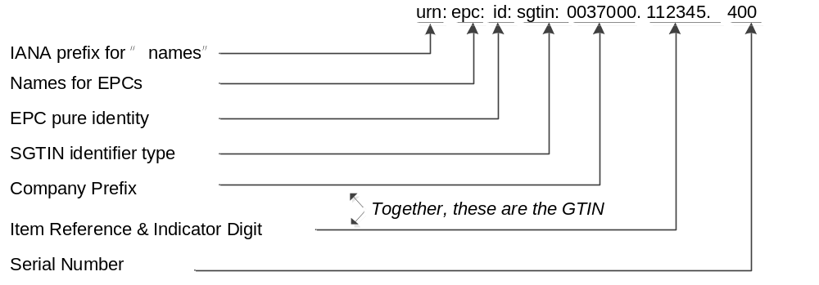
Figure 6.2-1 The overall structure of an EPC

EPCglobal network architecture is comprised of ONS (Object Name Service), and EPCIS (EPC information service). ONS is designed for resolving information associated with a EPC identifier, which means other identification types can not be recognized and resolved by the system. ONS uses the Domain Name System (DNS) infrastructure and implementation, thus the item’s EPC identifier must be converted into a format that DNS can understand, which is the typical, “dot” delimited, left-to-right form of all domain names, so as to accomplish the identification resolution, and then retrieving the information about the item. The resolution procedure is shown in Figure 6.2-2, and the detailed illustrations are as follows:

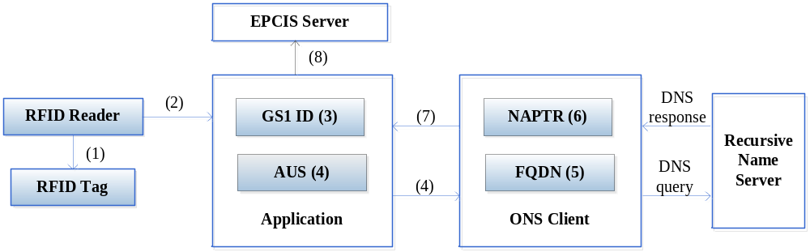
Figure 6.2-2 ONS resolution procedures
- A EPC identifier is read from a barcode or an RFID tag using an appropriate reader.
- The reader sends that sequence of data to an ONS application.
- The ONS application extracts the desired GS1 Identification Key type and the GS1 Identification
Key itself from the data. For example, a contained GTIN is 50614141322607.
- The ONS application sends the GS1 Identification Key type, the GS1 Identification Key itself,
and the optional codes that are the client language code and client country code to the ONS client. For
example, it is configured to operate in English in Canada: en|ca|gtin|50614141322607.
- The ONS client converts the GS1 Identification Key type and the GS1 Identification Key into an
appropriate FQDN as a DNS query, implementing“dot” delimited and left-to-right form, for example: 5.0.6.2.2.3.1.4.1.4.1.6.0.gtin.gs1.id.onsepc.com.
- The DNS infrastructure with contains service types and associated data, for example, the URLs point to one or more EPCIS.
- The ONS client extracts the service type and the service data and sends it to the ONS application.
- The application interprets the data and communicates the EPCIS server according to the resolved URL.

6.3 Handle Identifier
The Handle System was originally developed at CNRI (The corporation for National Research Initiatives). Each handle identifier is globally unique within the context of the Handle System. It consists of two parts: naming authority (prefix) and local name (suffix), and the structure is as followed:
<Handle> ::= <Handle Naming Authority> "/" <Handle Local Name>
The naming authority and local name are separated by the ASCII character "/". The naming authorities are defined in a hierarchical tree structure, the root and nodes of the tree are separated by the ASCII character ".".
For example, "10.1045/january99-bearman" is a handle identifier for an article. Its naming authority is "10.1045", there into “10” is the root naming authority, and “1045” is the subordinate naming authority. Its local name is "january99-bearman".
The Handle System defines a hierarchical service model. The Global Handle Registry (GHR) is at the top level, which can be used to manage any handle namespace, and the Local Handle Services (LHS) is at the lower level, which can be used to manage any handle namespace.
A typical handle resolution procedure is shown in Figure 6.3-1, and the detailed illustrations are as follows:
- The client sends a query to Global Handle Registry to resolve the handle “10.123/456”.
- The Global Handle Registry returns the service information of the Local Handle Service A that is responsible for the handles under the naming authority “10.123”.
- The client sends a query to the Local Handle Service A to resolve the handle “10.123/456”.
- The Local Handle Service A resolves the Handle, and then responses the result.
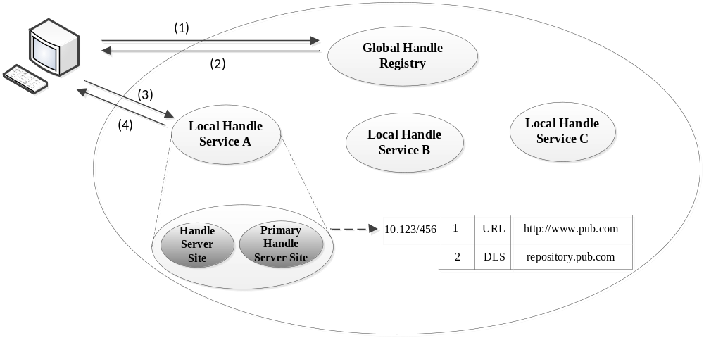
Figure 6.3-1 Handle system resolution procedures

6.4 Ubiquitous Code (ucode)
ucode is supported by the uID center, which is a non-profit organization based in Japan. A ucode is an identifier based on an encoding strategy to uniquely identify individual “objects”, “places” and “concepts” in the real world. "Objects" include tangible objects (e.g. industrial products, agricultural crops) and intangible objects (e.g. Internet content, programs). “Places” include the real world features such as roads and buildings. “Concepts” include the relationships between "objects" and "places" and the information which can be the real world context.
The ucode consists of five fields: Version, Top Level Domain Code, Class Code, Second Level Domain Code, and Identification Code. The basic ucode width is 128 bits, and it can extend the width in 128-bit units. The structure is shown in the Table 6.4-1.
Table 6.4-1: the structure of ucode
 | version | TLD Code | Class Code | SDL Code | Identification Code
ucode-128 | 4bits | 16bits | 4bits | 20-40bits | 24-4bits

The version indicates a ucode version number. The Class Code indicates the boundary between the Second Level Domain Code (SLDc) and the Identification Code (ic). The TLD is a domain allocated to organizations authorized by Ubiquitous ID Center. The SLD is a domain allocated to organizations authorized by the TLD management organizations.
The ucode server architecture is a multilevel hierarchical structure. In the architecture, the ubiquitous communicator (UC) retrieves the ucode and then gets the information server address by ucodeRP (ucode resolution protocol), and accesses the information associated with the identified “objects/places”.
A typical ucodeRP resolution procedure is shown in Figure 6.4-1, and the detailed illustrations are as follows:
- UC captures a ucode from a tag.
- UC sends a request that containing the ucode to the ucode resolution server, and gets the location information (e.g. 192.168.1.1) of the ucode resolution server for managing a CC field.
- UC sends a request that containing the ucode to the ucode resolution server for managing a CC field and gets the location information (e.g. 192.168.2.1) of the ucode resolution server for managing an SLD.
- UC sends a request that containing the ucode to the ucode resolution server for managing an SLD and gets the location information (e.g. http://www.uidcenter.org/getinfo.cgi) of the information server.
- UC sends the ucode to the information server and gets content.

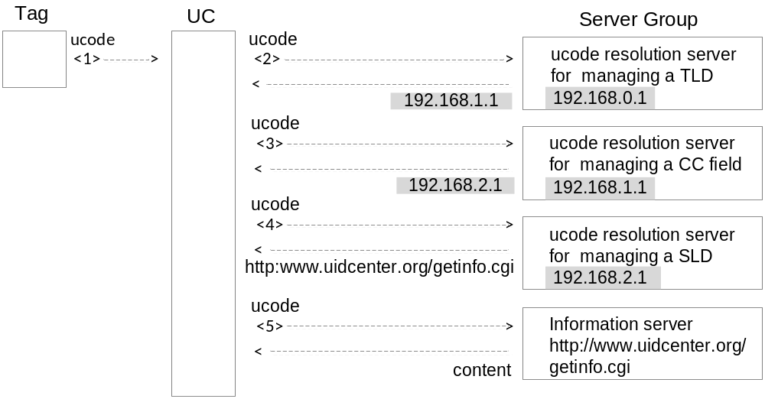
Figure 6.4-1 ucodeRP resolution procedures

6.5 Object Identifier (OID)
OID is jointly developed by both ISO/IEC and ITU-T. It is an encoding strategy and used to unambiguously identify an object (physical/virtual objects) uniquely in the global context. It ensures that the object can be addressed and managed absolutely.
OID uses a hierarchical tree structure. An OID consists of several segments called arcs which provide placeholders for identification and description in the hierarchical tree. In the OID tree, the first arc represents the organization code and is used to manage and allocate its corresponding lower arc. The first arc (nodes under the root) can be the value “itu-t (0)”, “iso (1)” and “joint-iso-itu-t (2)”, and the arcs from each node can be infinite. The OID structure is shown in the figure. OID resolution system (ORS) is a DNS-based protocol.
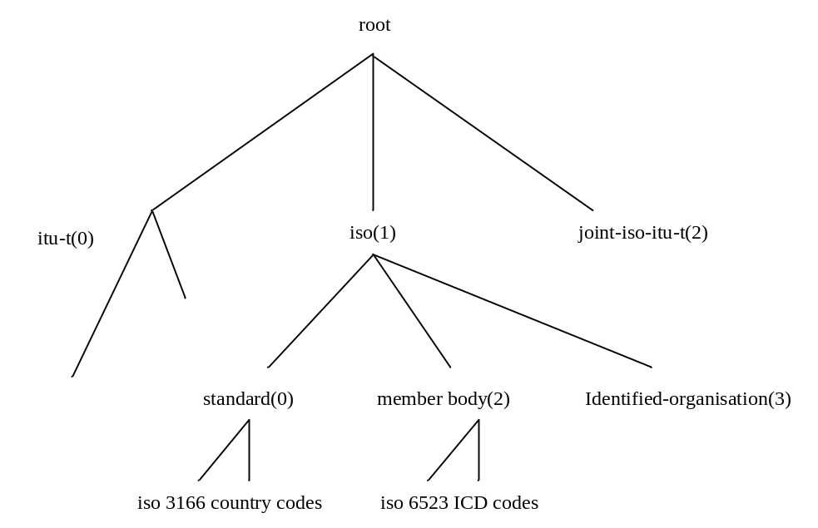
Figure 6.5-1 the structure of OID

7 Use cases analysis

7.1 Overview
A heterogeneous identification service is a common technology widely used in various IoT industries. For example, supply chain management and logistics, product traceability, and energy management.
There are three requirements related to the heterogeneous identification service that are not yet supported by the oneM2M system.
Requirement ID | Description | Release
OSR-111  See REQ-2017-0018R01 | The oneM2M system shall be able to support heterogeneous identification services, the recognition of external identification systems and converting an object identifier to a compatible identifier recognized by the oneM2M system.
The oneM2M system shall be able to support the traceability linking service which provides a mapping that relates a product identifier to product related traceability information.
Traceability information consists of:
  - Logs
  - Information on ID service nodes, such as:
    - servers that provide access to traceability information, and
    - devices (sensors and gateways) that gather traceability information
 | The oneM2M system shall be able to enable applications to retrieve the traceability information related to product identifiers.

Use case for heterogeneous identification service

7.2.1 Description
In an industrial internet environment, a physical entity (e.g. raw material, component, intermediate product and finished product ...) is given a unique tangible identifier via a labelling technology (e.g. RFID tag, barcode, etc.). The tangible identifier can aid a device (e.g. barcode reader) in identifing, monitoring, and proxying on behalf of a physical entity. The same physical entity can be assigned multiple tangible identifiers.
Based on various identification standards(e.g. EPC, OID, ucode) to allow different devices and applications compatible with the various identification standards to identify, monitor and proxy on behalf of the same physical entity.
To help manage the multiple tangible identifiers that is assigned to a physical entity, a M2M service platform supports a heterogeneous identification service. When it receives a request with a tangible identifier, the M2M service platform detects the standard which the tangible identifier is compliant to, and interworks with the corresponding resolution server to resolve the tangible identifier to a communication identifier (e.g. IP address, FQDN) of the device that interworks to the physical entity.

7.2.2 Actors
- M2M service platform
- The entity that provides a heterogeneous identification service.
- Discovery application
- The discovery request initiator (e.g. vendor, processor, operator or the third party).
- Device
- The entity that interworks to the physical entity and reads its tangible identifier. It can be a sensor, actuator, RFID reader, or application server.
- Resolution server
- The resolution server (e.g. ONS, Handle system) is an entity to resolve the tangible identifier of the physical entity to the communication identifier of the device that interworks to the physical entity.
- Physical entity
The physical entity does not have the capability to communicate with other entities. It is tagged with a tangible identifier a device (e.g. RFID reader) can use to identify and record information about the physical entity.

7.2.3 Pre-conditions
The application registers to the M2M service platform. The M2M service platform supports a heterogenous identification service that interworks with one or more identification resolution servers.

7.2.4 Triggers
The application initiates a request to discovery a physical entity via a tangible identifier.

7.2.5 Normal Flow

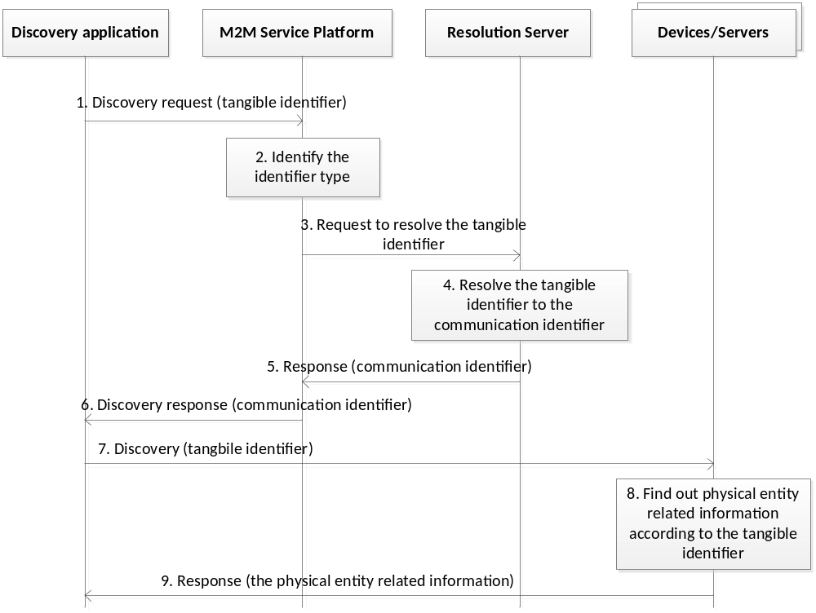
Figure 7.2.5-1 normal flow of heterogeneous identification service use case

- The discovery application initiates a request to discover a physical entity via its tangible identifier such that it can find the communication identifier of the device that interworks to the physical entity.
- The M2M service platform receive the request from the discovery application, identifies the standards which the tangible identifier is complaint with.
- The M2M service platform sends the tangible identifier to a request to resolve the tangible identifier to a corresponding resolution server.
- The resolution servers resolve the tangible identifier to the communication identifier of the device.
- The resolution servers respond with the communication identifier of the device to the M2M service platform.
- The M2M service platform forwards the communication identifier to the discovery application.
- The discovery application sends a request to the device that is interworked to the physical entity and includes the tangible identifier of the physical entity.
- The device processes the request.
- The device responds with information about the physical entity to the discovery application.

7.2.6 Alternative flow
None

7.2.7 Post-conditions
None.

7.2.8 High Level Illustration

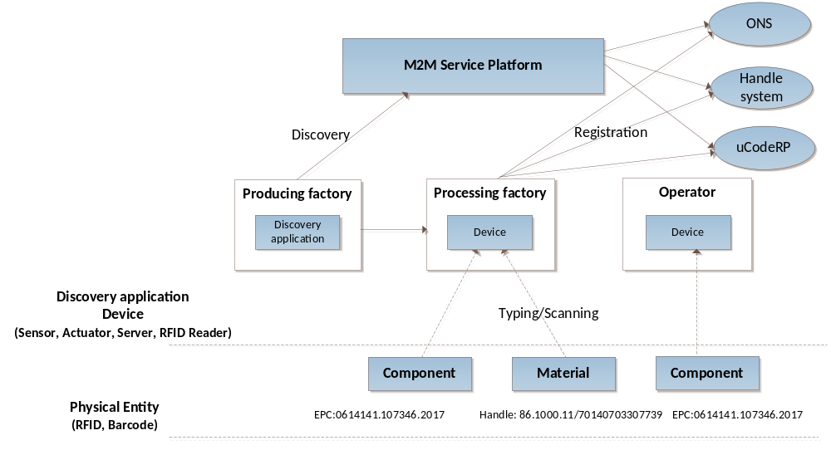
Figure 7.2.8-1 high level illustration of heterogeneous identification service

7.2.9 Potential requirements
- The oneM2M system shall be able to support heterogeneous identification services, the recognition of external identification systems resolving a tangible identifier of a physical entity to a communication identifier of device.

8 Potential enhancements to oneM2M

8.1 Scenarios analysis based on oneM2M architecture

8.1.1 Creation of mapping information
A oneM2M AE captures the tangible identifier from tag attaching to a physical entity and also captures other related information (e.g. location, time). The creation procedures are shown in Figure 8.1.1-1.

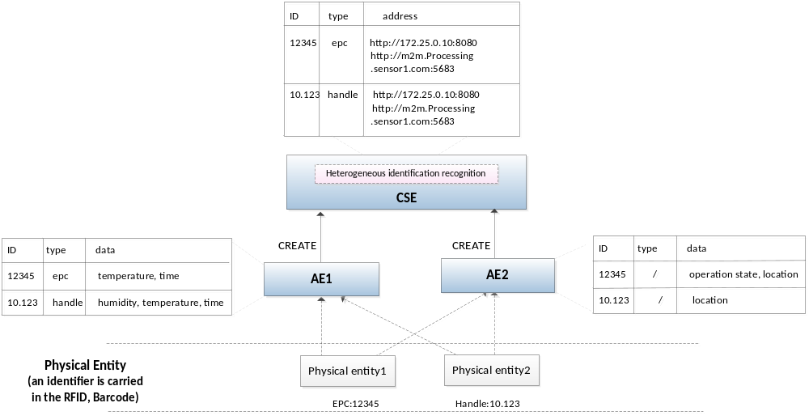
Figure 8.1.1-1 Creation procedures
- AEs (AE1, AE2) and potentially other information (e.g. location, time) of the physical entities.
- AEs optionally store the tangible identifiers, information (e.g. location, time) of the physical entities, identifier type, and the communication identifier of AE in the CSE. There are five possible combinations: 1) tangible identifier, information of the physical entity; 2) tangible identifier, communication identifier; 3) tangible identifier, information of the physical entity, identifier type; 4) tangible identifier, communication identifier, identifier type; 5) identifier type, communication identifier.

8.1.2 Discovery of identifiers related information
The application wants to discover the tangible identifier related information from the CSE that provides the heterogeneous service. There are two cases depicted as follows:
Case 1: the CSE4 maintains the tangible identifier related mapping information, the discovery procedures are shown in Figure 8.1.2-1.

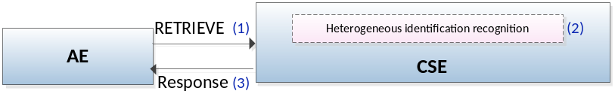
Figure 8.1.2-1 discovery procedures for case 1

- The discovery application AE3 initiates a request to discover device that interworks to a particular physical entity. The tangible identifier of the physical entity is included in the request.
- The CSE receives and processes the request. If the identifier type is not included in the request, the CSE can recognize the type of tangible identifier. The CSE resolves the tangible identifier to a communication identifier of the device that interworks to the physical entity.
- The CSE forwards the discovery results to the AE.

Case 2: the mapping information is not recorded on the queried CSE. The CSE will interwork with external identification resolution system(s) to assist with the identification resolution. The discovery procedure is shown in figure 8.1.2-2.

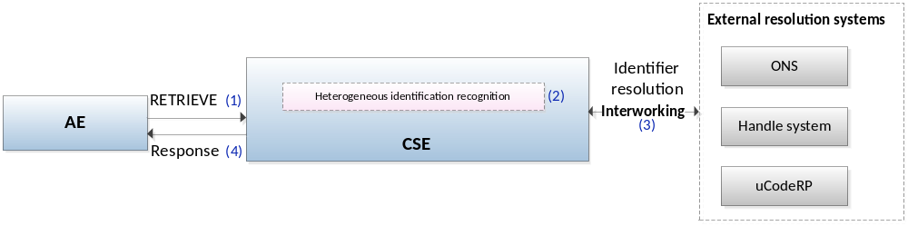
Figure 8.1.2-2 discovery procedures for case 2

- The discovery application AE initiates a request to discover the device that interworks to a particular physical entity. The tangible identifier of the physical entity is included in the request.
- The CSE receives the request. If the identifier type is not included in the request, the CSE can recognize the type of tangible identifier.
- The CSE sends the tangible identifier to the corresponding external resolution system (e.g. Handle system), and gets and resolution results from the resolution system. The results include the communication identifier of the device that interworks to the physical entity.
- The CSE responds with the discovery results to the AE.

8.2 Potential solutions

8.2.1 Discovery based on CSE identification resolution
As described in case 1 within clause 8.1.2, a oneM2M CSE can maintain information to resolve a tangible identifier of a physical entity to a communication identifier of a device that interworks to the physical entity. Using this information, the CSE can process and respond to discovery requests for physical entities based their tangible identifiers and return communication identifiers of the devices that interwork to these physical entities.
The following table proposes a new tangibleIDInformation attribute for the <container> resource. This attribute is used to store identifier information.
Table 8.2.1-1: Attribute of <container> resource
Attributes of  <container> | Multiplicity | RW/  RO/  WO | Description | <containerAnnc> Attributes
tangibleIDInformation | 0..1(L) | RW | This attribute represents a set of tangible identifiers and its related information. The attribute is comprised of a list of 3-tuples. Each 3-tuple shall consist of a tangibleID and/or IDType, and/or communicationID as defined in table 8.2.1.-2. | OA

The tangibleIDInformation attribute contains the parameters specified in table 8.2.1-2.
Table 8.2.1-2: Parameters in tangibleIDInformation attribute
Parameters in tangibleIDInformation | Multiplicity | Description
tangibleID | 0..1(L) | This parameter is a list of tangible identifiers associated with the specific physical entities. It is described as a list of tangible identifiers (e.g. 86.1000.11/70140703307739, 1.2.156.20000.2010319).  It shall be present in case IDType parameter is null.
IDType | 0..1 | It shall be present in case tangibleID parameter is null. If the tangibleID parameter is present, it represents the corresponding type of the tangible identfiers. If the tangibleID parameter is not present, it represents the identifier type that is supported by the creation originator. The identifier type is expressed in string：  - epc;  - handle;  - oid;  - ucode;  - mcode;  - ecode.
communicationID | 0..1 | It represents the physical address (e.g. IP address, FQDN) used by the device that that interworks to the physical entity.

8.2.2 Discovery based on interworking with external systems
As described in case 2 of clause 8.1.2, instead of maintaining information to resolve a tangible identifier of a physical entity, a CSE can instead interwork with external identification resolution systems to implement resolution. For example, a CSE can interwork with external identification resolution systems such as ONS, Handle system and uCodeRP.
      - Identification resolution systems register to oneM2M system via IPE

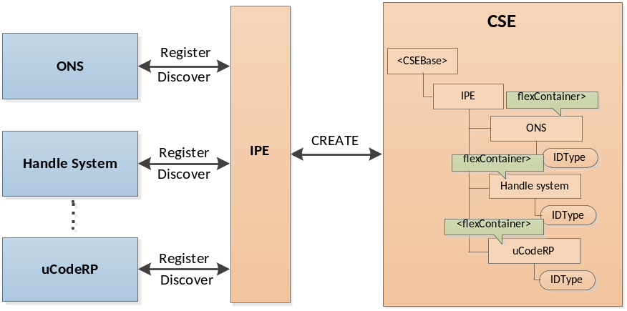
Figure 8.2.2.1-1: Identification resolution systems register to oneM2M system via IPE
Step 1: The external identification resolution systems register to the IPE, or IPE discovers them proactively.
Step 2: IPE registers to the CSE and creates an <AE> resource. The IPE then creates <flexContainer> resources for each identification resolution system. The structure of <IPE> resource tree is shown in Figure 8.2.2.1-2. Each <flexContainer> resource has an IDType attribute to indicate its supported type(s) of tangible identifier(s). The proposed format of the IDType attribute is a list of strings. For example, each element in the list can have values such as ‘epc’, ‘handle’, ‘oid’, ‘ucode’, ‘mcode’, etc.

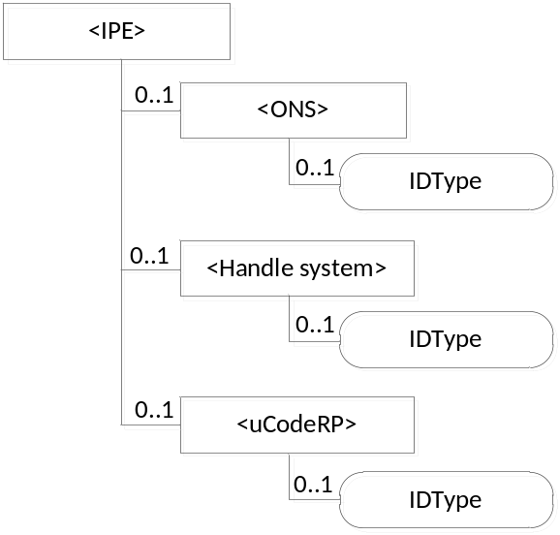
Figure 8.2.2.1-2: Structure of <IPE> resource tree on CSE

      - Identification resolution systems assist with discovery

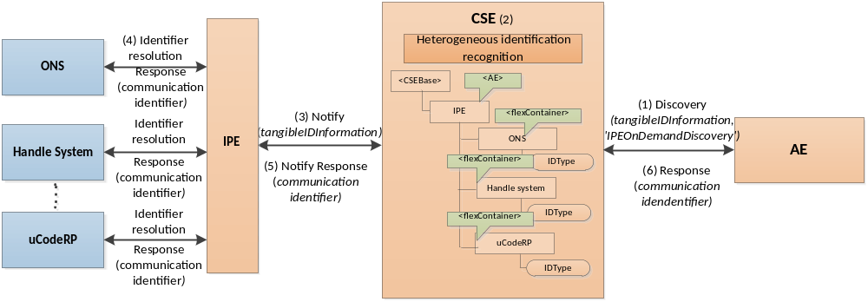
Figure 8.2.2.2-1: Procedure of discovery based on interworking with external systems

Step 1: AE (e.g. a query application) sends a RETRIEVE request to CSE (e.g. a service platform) to discover the information related to a tangible identifier. In the request, the Filter Criteria must set the conditions to filter the resource. The attribute element is configured with tangibleIDInformation, e.g. “tangibleIDInformation{tangibleID=1.2.156.20000.201031}”, and the filterUsage element is set to 'IPEOnDemandDiscovery'.
Editor's Note: Stage 3 specifications needs to be checked if the example query string having an attribute sub-element is supported.

Step 2: CSE receives the request.
Step 3: In the case that the CSE doesn’t store any information related to the tangible identifier, the CSE checks the filterUsage element. If it is set to "IPE On-demand Discovery", the CSE checks whether any identification resolution IPEs are registered to the CSE and whether they support the type of tangible identifier if specified in the discovery request. If identification resolution IPE(s) are registered, the CSE sends Notify request(s) to the IPE(s) with the tangibleIDInformation.
Step 4: The IPE interworks with external identification resolution system(s) to resolve the tangible identifier. The result is the communication identifier (e.g. IP address and port, FQDN, URI, etc) of the device that interworks to the physical entity..
Step 5: The IPE sends the Notify response including the communication identifier of the device that interworks to the physical entity to the CSE.
Step 6: The CSE sends the discovery result to AE that includes the communication identifier of the device that interworks to the physical entity. The AE uses this information to communicate directly with the device (e.g. to retrieve information about the physical entity).

Proforma copyright release text block
This text box shall immediately follow after the heading of an element (i.e. clause or annex) containing a proforma or template which is intended to be copied by the user. Such an element shall always start on a new page.
Notwithstanding the provisions of the copyright clause related to the text of the present document, oneM2M grants that users of the present document may freely reproduce the <proformatype> proforma in this {clause|annex} so that it can be used for its intended purposes and may further publish the completed <proformatype>.
<PAGE BREAK>

Annexes
Each annex shall start on a new page (insert a page break between annexes A and B, annexes B and C, etc.).
Use the Heading 9 style for the title and the Normal style for the text.
Annex <A>:
Title of annex (style H9)
<Text>
<PAGE BREAK>
Annex <B>:
Title of annex (style H9)
<Text>
B.1 First clause of the annex (style H1)
<Text>
B.1.1 First subdivided clause of the annex (style H2)
<Text>
<PAGE BREAK>

Annex <y>:
Bibliography
The annex entitled "Bibliography" is optional.
It shall contain a list of standards, books, articles, or other sources on a particular subject which are not mentioned in the document itself.
It shall not include references mentioned in the document.
Use the Heading 9 style for the title and B1+ or Normal for the text.
- <Publication>: "<Title>".
OR
<Publication>: "<Title>".
<PAGE BREAK>

History
This clause shall be the last one in the document and list the main phases (all additional information will be removed at the publication stage).
Publication history
V.1.1.1 | <dd Mmm yyyy> | <Milestone>

Draft history (to be removed on publication)
V..1.0 | 2017-07-10 | Incorporated contributions agreed at ARC#27 and ARC#29:  ARC-2017-0043R01-Skeleton_of_heterogeneous_identification_service  ARC-2017-0203R01-TR-0044_Introduction_to_heterogeneous_identification_service  ARC-2017-0204-TR-0044_Existing_technologies  ARC-2017-0205R01-TR-0044_Use_cases_analysis  ARC-2017-0206R01-TR-0044_Potential_enhancements
V.0.2.0 | 2018-03-13 | Incorporated contributions agreed at ARC#32.2 and ARC#33:  ARC-2017-0431R04-CR-TR-0044-Potential_solution  ARC-2018-0004-TR-0044_clean_up

